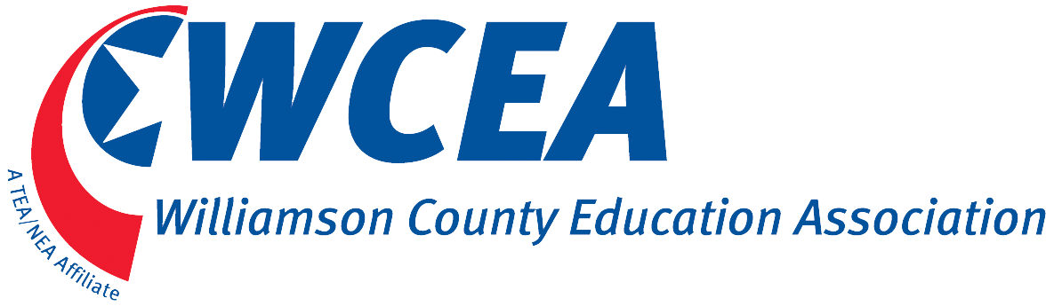
Williamson County Education Association is proud to offer the Kawanda Braxton Memorial Scholarship of $1000. Kawanda Braxton was a fine educator who taught in Williamson County Schools and served as president of WCEA. We honor her years of dedication to the teaching profession by offering this scholarship to a worthy candidate. The applicant must be the child of a WCEA member and a high school senior planning to seek a degree in Education.
Please include the following with your application:
- A current resume, including a list of activities (school, community, religious) in which you have been involved that illustrates your interest in children/youth.
- Official high school transcript submitted in sealed envelope from high school guidance counselor.
- College acceptance letter.
- Write an essay describing experiences that led to your desire to become an educator. Essay specifications: Two, but no more than 2 and one-half pages, double-spaced, with one-inch margins, and size 11 font (use a font that is easily read, i.e. Ariel, Times New Roman, etc.).
- Two letters of recommendation: one from a current or former teacher and one from an individual(not a teacher) who can comment on your character and dedication to children/youth.
Please print in blue or black ink.
Name: __________________________________________________________________________________ Date of Birth ______________________

Address____________________________________________ City:_________________________ State:______________ Zip___________________

Phone(home)________________________________ (cell) ____________________________ Email: _______________________________________

School currently attending: ____________________________________________________

School Address:_________________________________________________ City:__________________ State:______________ Zip______________

College/University you plan to attend: ____________________________________ Grade level & Subject you plan to teach____________________

High School GPA: ________________________
I affirm that the above information is correct to the best of my knowledge.

Applicant signature ___________________________________________ Date________________________
Questions contact loisc@wcs.edu Application deadline: April 8, 2019
Send your completed application to Lois Coles, Brentwood Middle School, 5324 Murray Lane, Brentwood, TN 37027

